MACH4METAL

Metalworking machinery
Transito 21,
6909 DA BABBERICH
Netherlands
Tel. +31 (0)316 – 247123
Fax. +31 (0)316 - 247956
info@mach4metal.com
www.mach4metal.com

Account No: 66.52.13.883
IBAN : NL33 INGB 0665 2138 83
BIC : INGBNL2A

UNION HECKERT Ti 1800 Rotary table
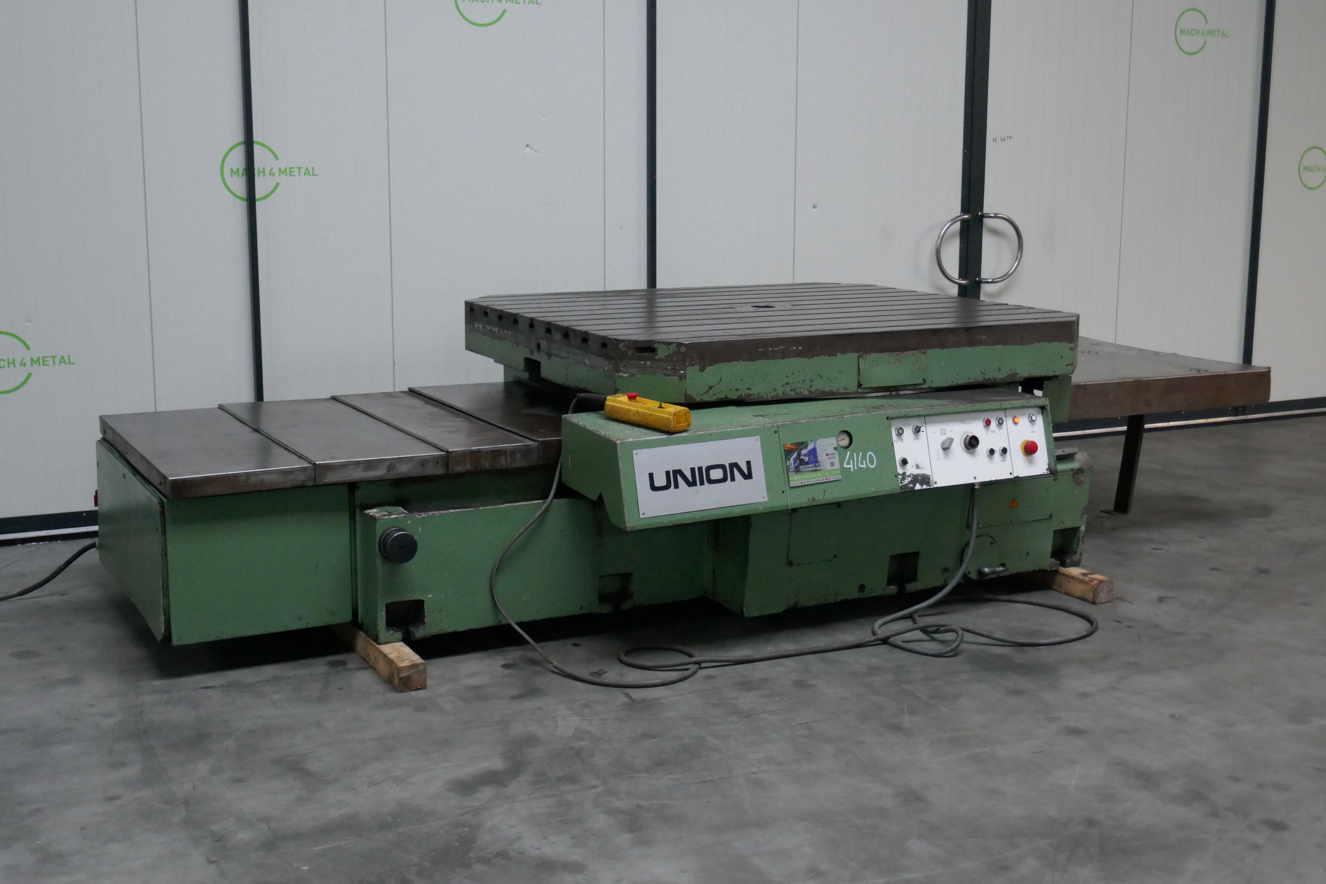
- Make : UNION HECKERT
- Type : Ti 1800
- Mach. No : 7720 / 70111
- Age : 80 er

- Table length : 2.000
- Table width : 1.800
- Table load Kg : 12.000
- V – Travel on bed : 1.250
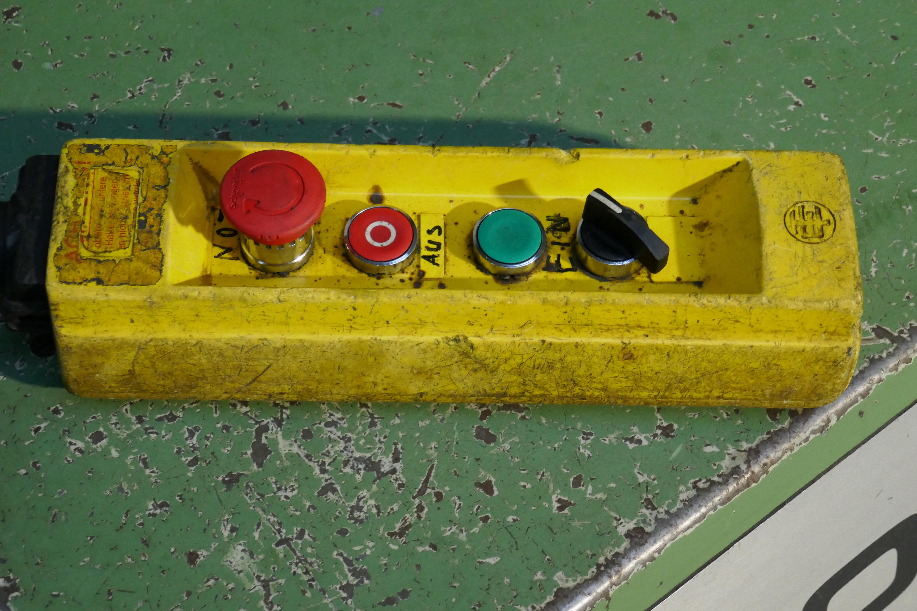
- Table rotation speed : Rpm
- Rapid ration speed : Rpm
- Table rotation : 360 gr.

- Feed in V axis on bed : 0,5 – 1.600 mm/min
- Rapid movement V axis: 6.475 mm/min

- Heavy bed way construction
- Power motor indexing : 6 Kw
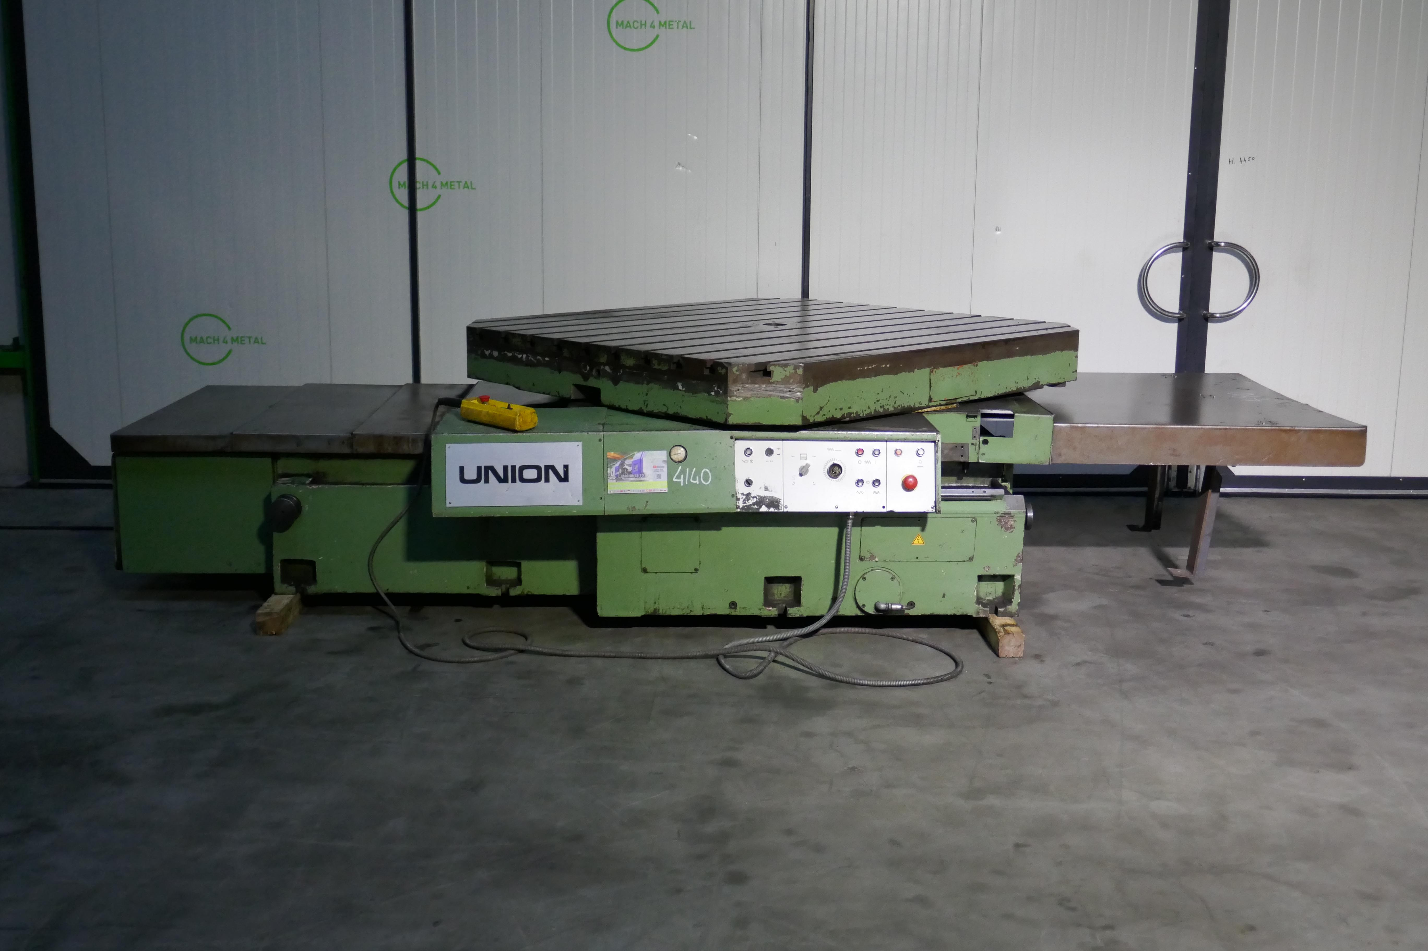

- Over all length : 3.000
- Width : 2.000
- Height : 1.000
- Weight : ca. 7 Ton

- Readout for position V Axis
- Readout for position Gr. Rotation

Please Note: The above information has been obtained to the best of our ability and belief from, and from the manufacturers where possible. It is given in good faith, but its accuracy can not be guaranteed. Accordingly, it will not form a representation or constitute contractual terms. We advise you to check any vital details!

